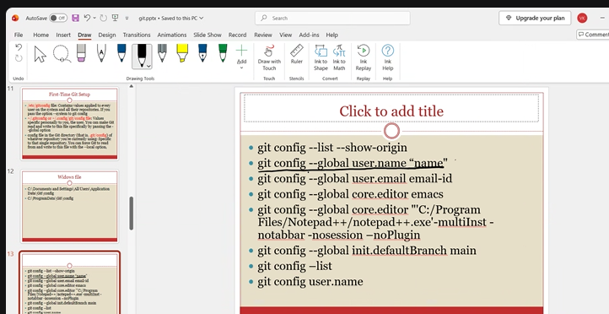

# to check how many times commit happened
git log
$ git log
commit ae351d805a94263a9a67ee1a2b1f6503d167b3e9 (HEAD -> main)
Author: Akash Pawar <skylaryan16@gmail.com>
Date: Sun Oct 25 09:36:20 2026 +0530

Third commit

commit b8439a61e95bd8a9cef9d03472320eaa6a509c8a
Author: Akash Pawar <skylaryan16@gmail.com>
Date: Sun Oct 25 09:35:11 2026 +0530

Second commit

commit feecb96b7fc21e2ed27cb3eca13b33a0bb7b656f
Author: Akash Pawar <skylaryan16@gmail.com>
Date: Sun Oct 25 09:33:57 2026 +0530

First commit

$ git log --oneline
ae351d8 (HEAD -> main) Third commit
b8439a6 Second commit
feecb96 First commit

#Difference
$ git diff ae351d8 b8439a6
diff --git a/file1 b/file1
index 6da4d3e..7d91453 100644
--- a/file1
+++ b/file1
@@ -1,3 +1,2 @@
First line
Second line
-Third line

#to check difference between two add (Working area) (staging area)
No comites done but one is added to staging area and other is not yet added

$ git diff
warning: in the working copy of 'file1', LF will be replaced by CRLF the next time Git touches it
diff --git a/file1 b/file1
index 5028ae5..fbc4b28 100644
--- a/file1
+++ b/file1
@@ -2,3 +2,4 @@ First line
Second line
Third line
Fourth line
+Fifth line

#to check difference between two commits which are done already

Akash Pawar@DESKTOP-14H8CE8 MINGW64 /d/git_test (main)
$ git diff --cached
diff --git a/file1 b/file1
index 6da4d3e..5028ae5 100644
--- a/file1
+++ b/file1
@@ -1,3 +1,4 @@
First line
Second line
Third line
+Fourth line

502 cd /d
503 ls -lrt
504 mkdir git_test
505 cd git_test
506 git init
507 echo "First line" > file1
508 git status
509 git add file1
510 git status
511 git commit -m " First commit"
512 echo "Second line" >>file1
513 git status
514 git add file1
515 git commit -m " Second commit"
516 echo "Third line" >>file1
517 git status
518 git add file1
519 git status
520 git commit -m " Third commit"
521 git log
526 git log --oneline
527 git diff ae351d8 b8439a6
528 history
529 echo "Fourth line" >>file1
530 git status
531 git add .
532 echo "Fifth line" >>file1
533 git status
534 git diff
535 git diff --cached
536 history | tail -10
537 git remote add origin https://github.com/skylaryan16-netizen/Git_Commands_n_Documents.git
538 git branch -M main
539 git push -u origin main
540 git config --global user.name "skylaryan16-netizen"
541 git config --global user.email "skylaryan16@gmail.com"
542 git push -u origin main
543 git status
544 git add all
545 git add .
546 git commit -m "end "
547 git push -u origin main
548 history | tail -10
549 history | tail -15

